Name: Divyansh Dubey

Roll no: 231070001

Course: DAA  
Program: B. Tech Computer Engineering

**Assignment 1**

Problem:

Understand the process of finding  
SPI and CPI.  
  
Write an algorithm for the same.  
Write a program to solve given problem using your algorithm.  
  
Submit  
1. Algorithm  
2. Sample input and out put (test cases) minimum 5 different values  
Write 50% positive test cases and 50 % negative test cases  
  
  
3. Program  
4. Test the program for the above test cases  
  
5. Conclusion

Solution:

Algorithm: -

* Step1: Start.
* Step2: Read Choice.
* Step3: if(choice==1)

Go to step 4

Elseif(choice==2)

Go to step 5

Else

Go to step 6.

* Step4: Read SPI for all semesters

CPI= Sum of all SPI/Total credit points attempted.

Print CPI

Go to step 7.

* Step5: Read Semester number

Read all Grades of all subjects of that semester

SPI= Sum of grades of all subjects/Total credit points of that semester

Print SPI

Go to step 7

* Step6: Print (Please Enter valid input)

Go to step 3.

* Step7: Stop.

Sample:

Test Case 1:

2

1

Grade[1]= 7, Grade[2]= 8, Grade[3]= 6, Grade[4]= 8, Grade[5]= 5.

SPI= 6

Test Case 2:

2

2

Grade[1]= 5, Grade[2]= 7, Grade[3]= 6, Grade[4]= 5, Grade[5]= 5.

SPI= 5.25

Test Case 3:

1

SPI[1]= 8, SPI[2]= 6, SPI[3]= 8, SPI[4]= 9, SPI[5]= 7, SPI[6]= 9, SPI[7]= 8, SPI[8]= 8;

SPI= 8.15

Test Case 4:

2

5

Grade[1]= 8, Grade[2]= 7, Grade[3]= 9, Grade[4]= 9, Grade[5]= 7.5

SPI= 8.25

Program:

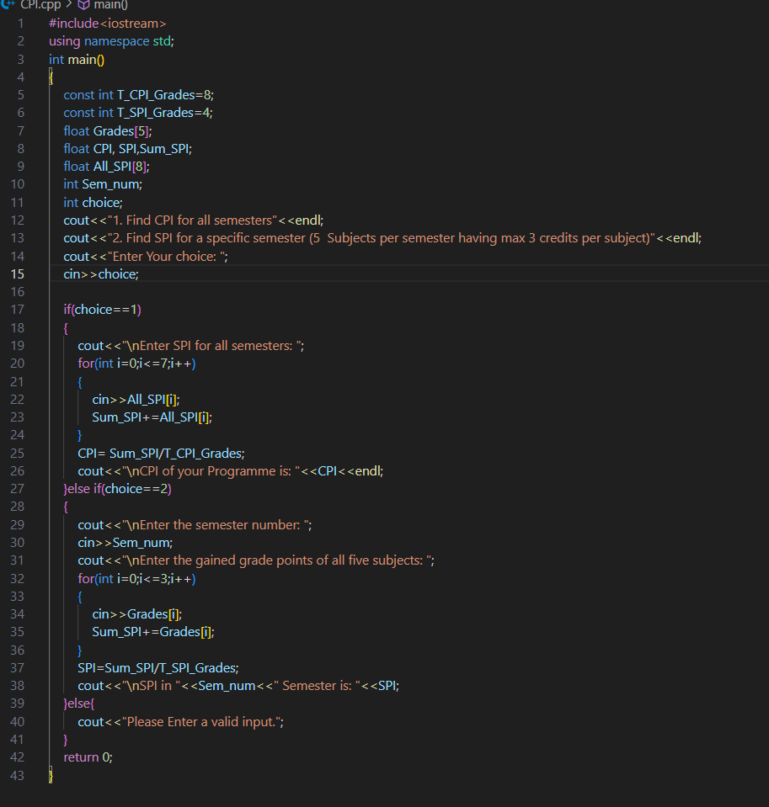

Output:

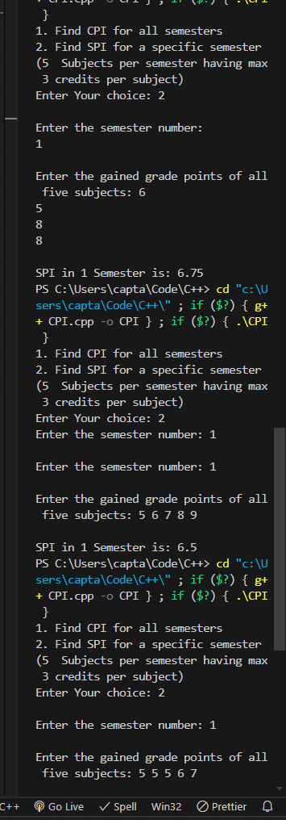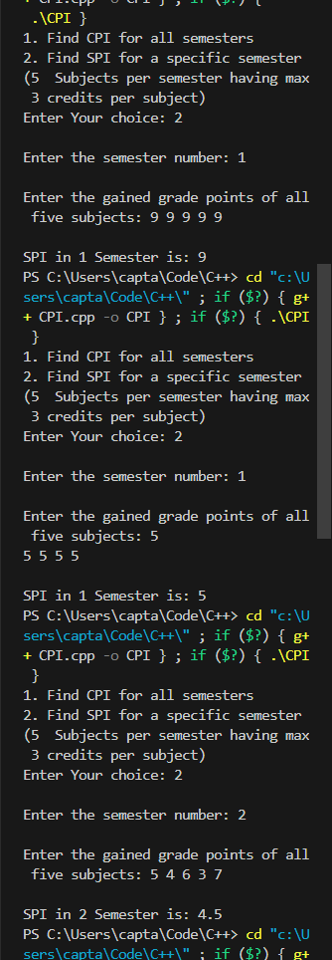

Conclusion:

Overall, the algorithm efficiently manages the calculation of academic performance metrics while providing user-friendly error handling. It ensures that valid calculations are performed based on user choices and maintains a robust interaction loop for handling erroneous inputs.